Abstract Example for PBAST8: How to Correctly Prepare Your Abstract for the 8th Pacific Basin Conference on Adsorption Science and Technology
Please leave this space (5cm x 3.5 cm from the upper right corner) open. If you are directly using this file as a template, please do not forget to remove this text box before converting your word file to a pdf file.
Hanako Hokkaido^{*1,2}, Taro Sapporo¹ and Jiro Kitaku³
¹Department of Adsorption Science and Technology, Faculty of Chemistry, Adsorption University, 1-1-1 Adsorption St., Sapporo 060-8628, Japan, ²CRESTO, JST, ³Adsorption Industry Corp.
*Corresponding author, e-mail pbast8@gmail.com, fax +81-11-000-0000

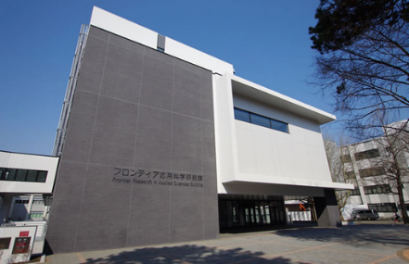
Your abstract should be prepared in a camera-ready form as a PDF file. All the figures, schemes, tables and manuscript should be included in one file. The size of paper should be A4 (21.0 cm x 29.7 cm), and the margin for all sides should be set to 2 cm (if A4 size is not available, please use the paper size of 8” x 11”, and adjust the margins so that the usable space will be 17.0 cm x 25.7 cm (6.7” x 10”) ). Only 1 page is allowed. Please use “Times New Roman” or “Times” fonts (or something similar if both fonts are not available) with a size of 12 pt. Line spacing should be set to 1.0 (18 pt). The total number of lines, including blank lines, should then be 40. Start the abstract with your title. The title should be capitalized, and should be written using bold fonts as shown above. A line including the name(s) of the author(s) should follow. The name of the presenting author should be underlined, and the name of the corresponding author should be marked with an asterisk. The affiliation number(s) of each author should be indicated as a superscript after each name. After the line of author(s), a list of the affiliation(s) of the author(s) should follow. Regarding the address(es) of the affiliation(s), only the contact address of the corresponding author is required. When listing the affiliation(s), please indicate its number as a superscript, first. After the affiliation list, a line indicating the e-mail address and the fax number of the corresponding author, and a blank line should follow. After the blank line, the body of the abstract should start. Figures and Tables can be inserted into the body. They must be numbered, for example, as “Table 1, Table 2, Figure 1, Figure 2” even when there is only one Figure or Table. Please note that the abstracts will be printed in black and white. When equations are included, they should also be numbered as follows:
Figure 1. Conference Venue

A + B → C +D (1)

Please insert a blank line prior to and after the equation. References should be listed at the end of the abstract, and numbered in the order of their appearance in the abstract body. The number of each reference should be given in square brackets [ ]. In the reference list, periodicals [1], books [2], and proceedings [3] should be listed following the format of the examples shown below

[1] K. Kaneko, C. Ishii, M. Ruike and H. Kuwabara, Carbon, 30 (1992) 1075.
[2] D. D. Do, Adsorption Analysis: Equilibria and Kinetics, Imperial College Press, 1989, p. 91.
[3] K. Ho, A.-T. Vu, S. Jin, J-B Lee and C-H Lee, Proc. PBAST-7, Xiamen, 24-27 Sept. 2015.

